**While Loop**

* Control flow statement which executes the block of codes indefinite number of times until the given condition become false.

while some condition (or expression) :

a block of code

* 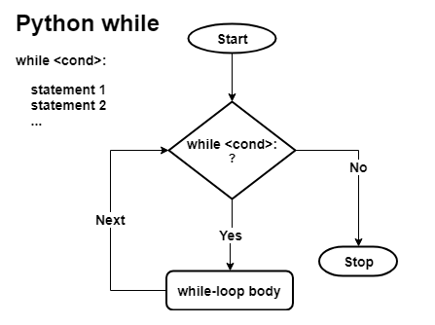
* r1 = int(input("Enter the starting range value?"))
* r2 = int(input("Enter the ending range value?"))
* num = r1 + 1
* count = 0
* while num < r2:

if (num % 2) > 0:

* count += 1
* num += 1
* print("Odd count: %d" % (count))

**Else clause with While loop**

Else block will run after the execution of the while loop.

It won’t run is if the loop exits after a “**break**” statement.

def while_else_demo():

count = 0

while count < 5 :

num = int(input("Enter number between 0-100?"))

if (num < 0) or (num > 100):

print("Aborted while: You've entered an invalid number.")

break

count += 1

else:

print("While loop ended gracefully.")

while_else_demo()